Batch: C2 Roll No.: 16010121200

Experiment 05

Grade: AA / AB / BB / BC / CC / CD /DD

Title: Working with time-series data.

Objective:

Search/locate and download the time series Data

To learn how to visualize time series data in Tableau

Applying trend line over visualized time series data using analytics options in tableau

Perform forecast over the time series using analytics options in tableau

Course Outcome:

CO1: Learn how to locate and download datasets, extract insights from that data and present their findings in a variety of different formats.

CO3 Apply data visualization best practices

Books/ Journals/ Websites referred:
https://www.investopedia.com/terms/t/timeseries.asp
https://towardsdatascience.com/time-series-from-scratch-decomposing-time-series-data-7b7ad0c30fe7

Resources used:
Tableau

Theory:
A time series is a data set that tracks a sample over time.
In particular, a time series allows one to see what factors influence certain variables from period to period.
Time series analysis can be useful to see how a given asset, security, or economic variable changes over time.
Forecasting methods using time series are used in both fundamental and technical analysis.

Definition Time series: A time series is a sequence of data points that occur in successive order over some period of time.

Following points should be written by students

Observation after plotting of time series data
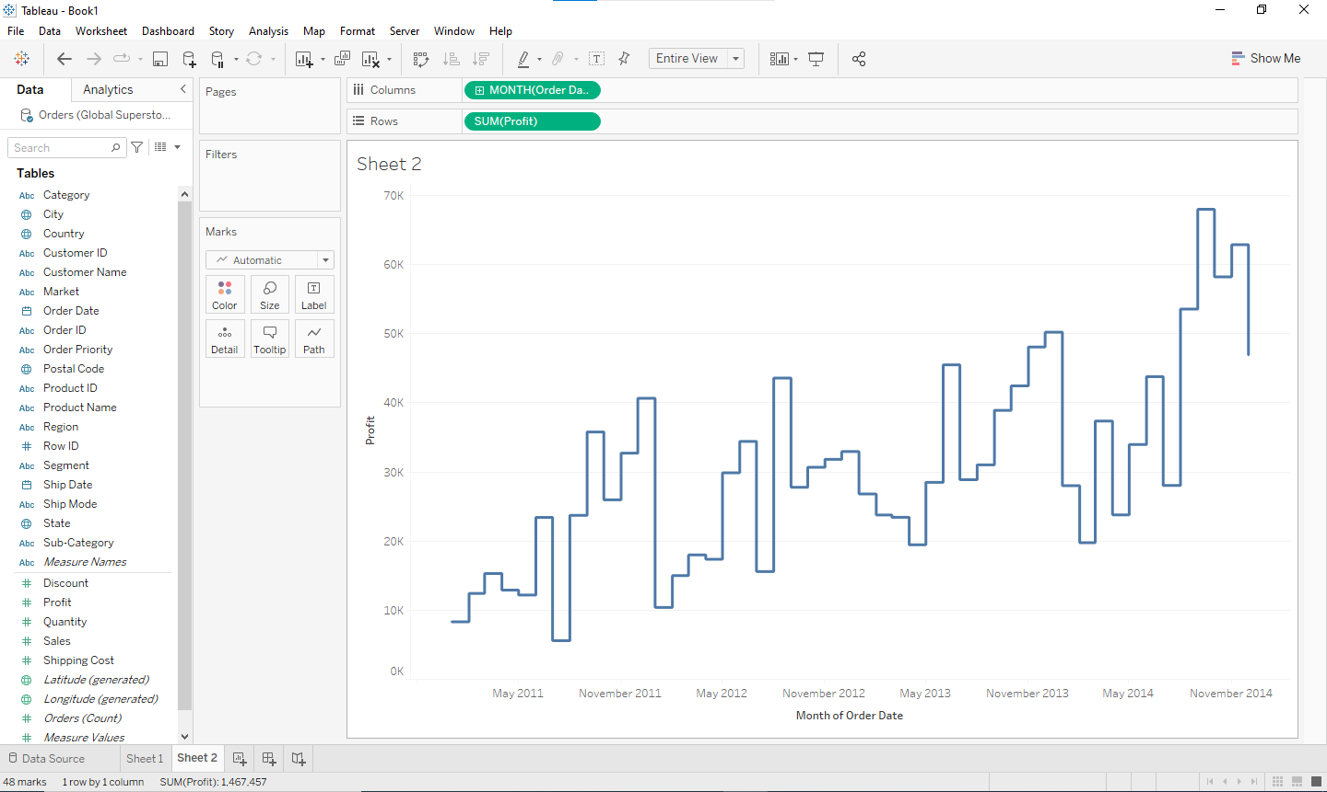

Observation after plotting trend line (Linear, Exponential, and polynomial)
Linear trend:
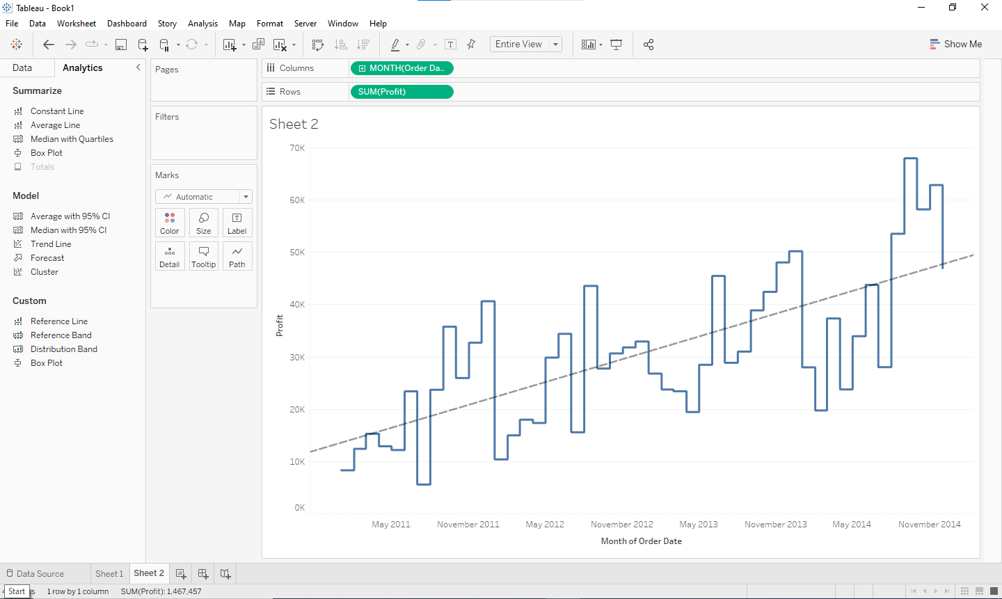
Exponential Trend:
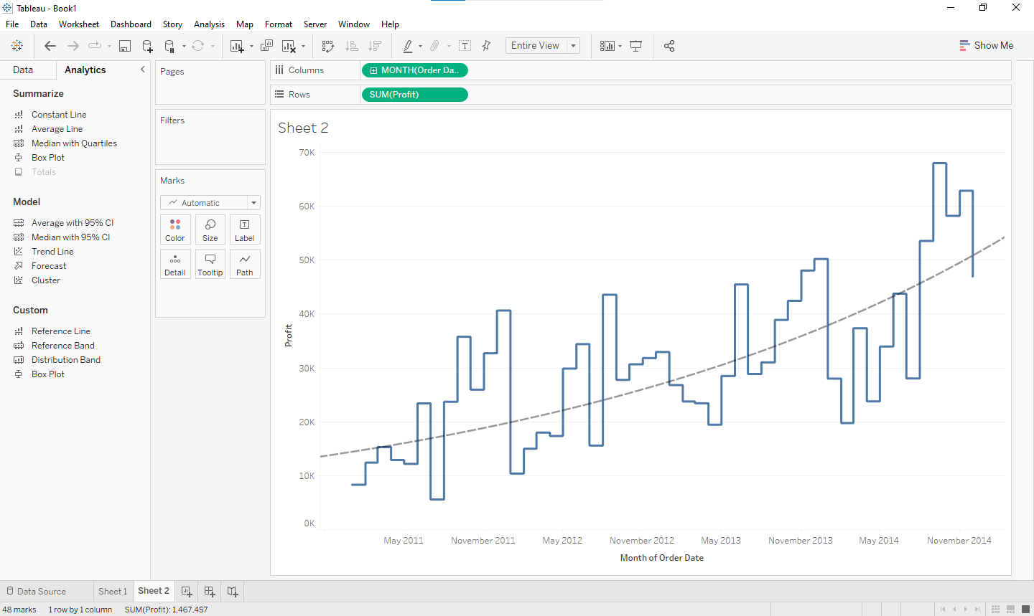

Polynomial Trend:
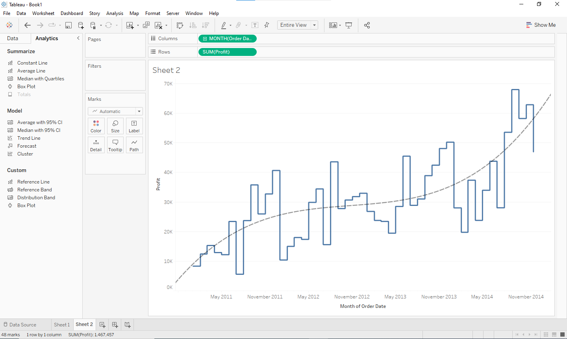

Observation after Forecast (Automatic, Additive, and multiplicative, along with season options)
Linear Trend:
Automatic
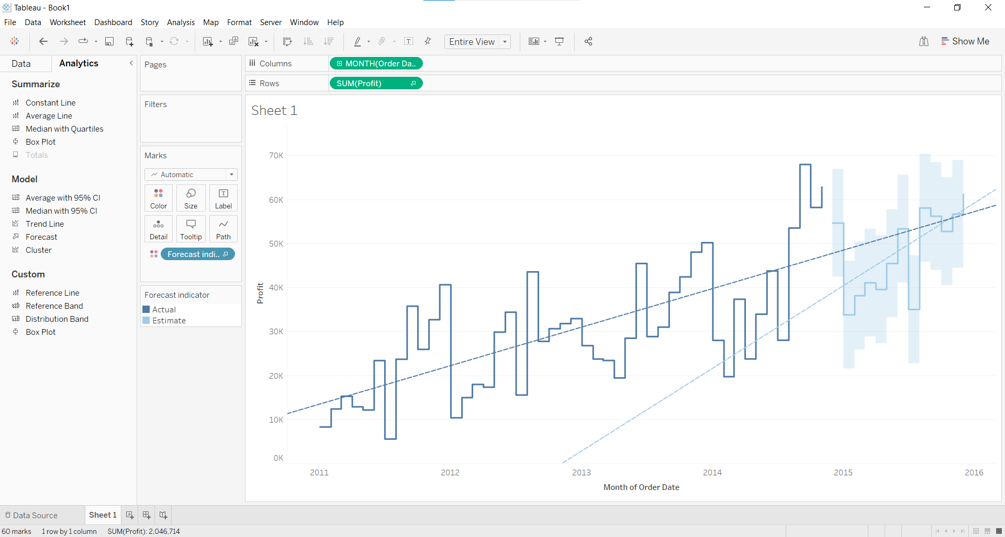
Automatic without seasoning
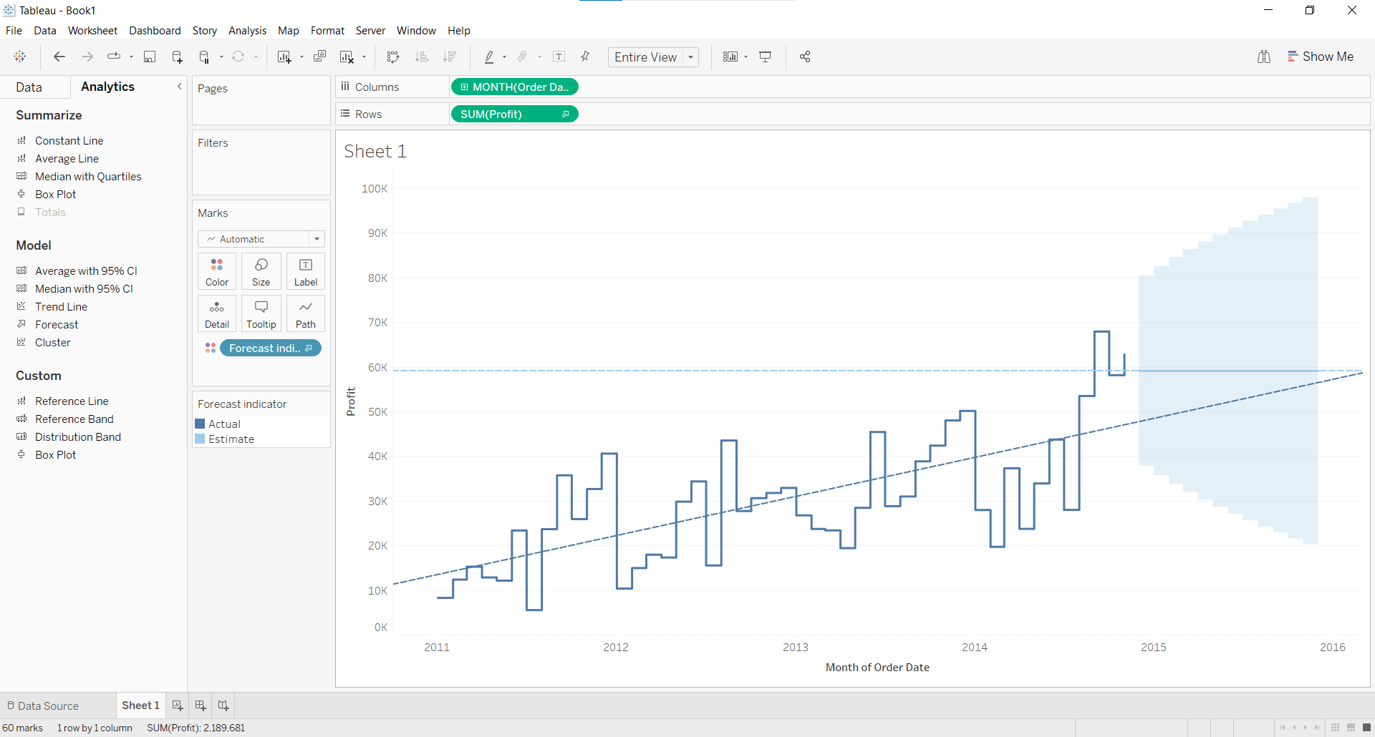

Additive Trend and Additive Seasonality
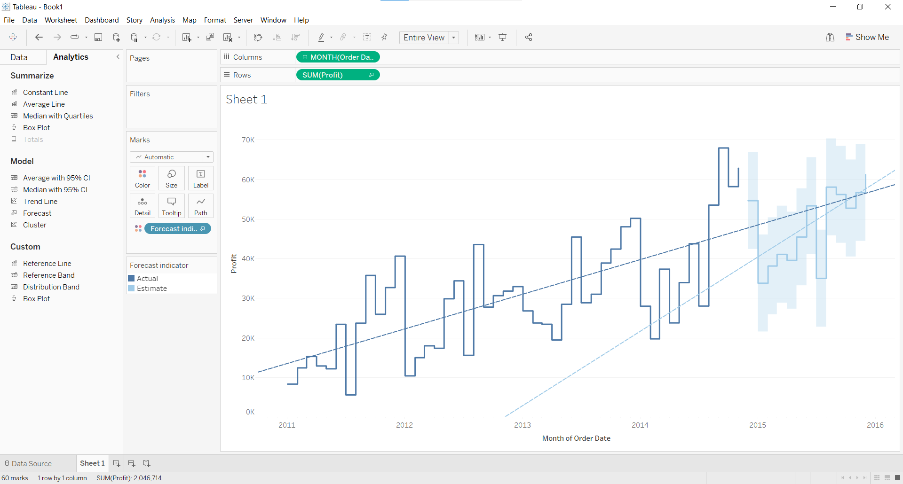
Additive Trend and Multiplicative Seasonality
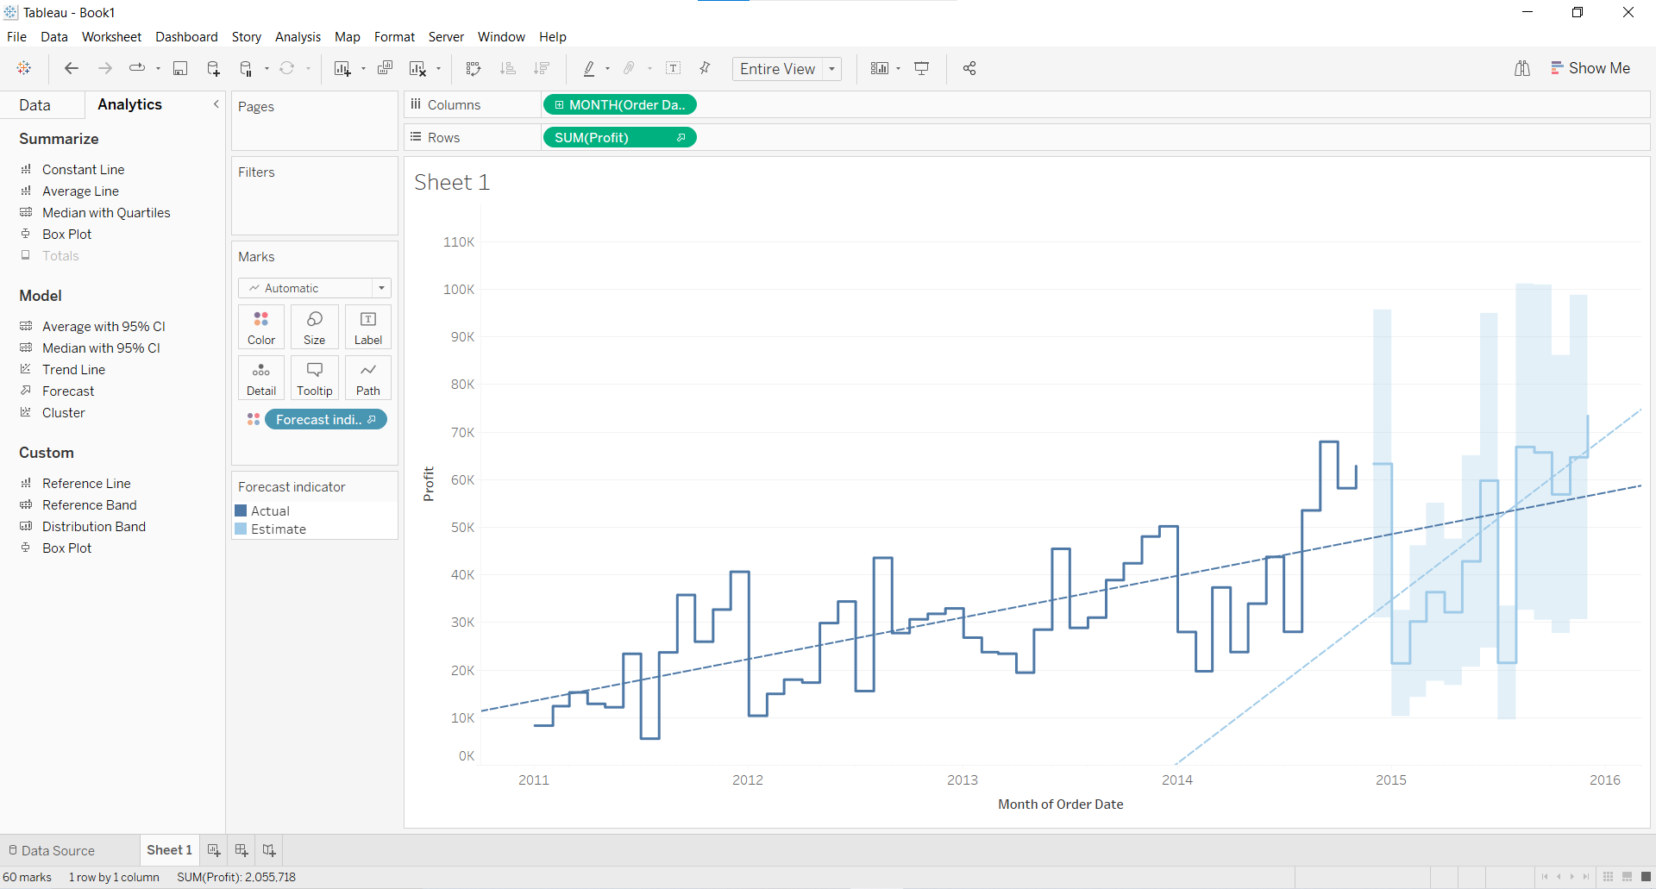
Multiplicative Trend and Multiplicative Seasonality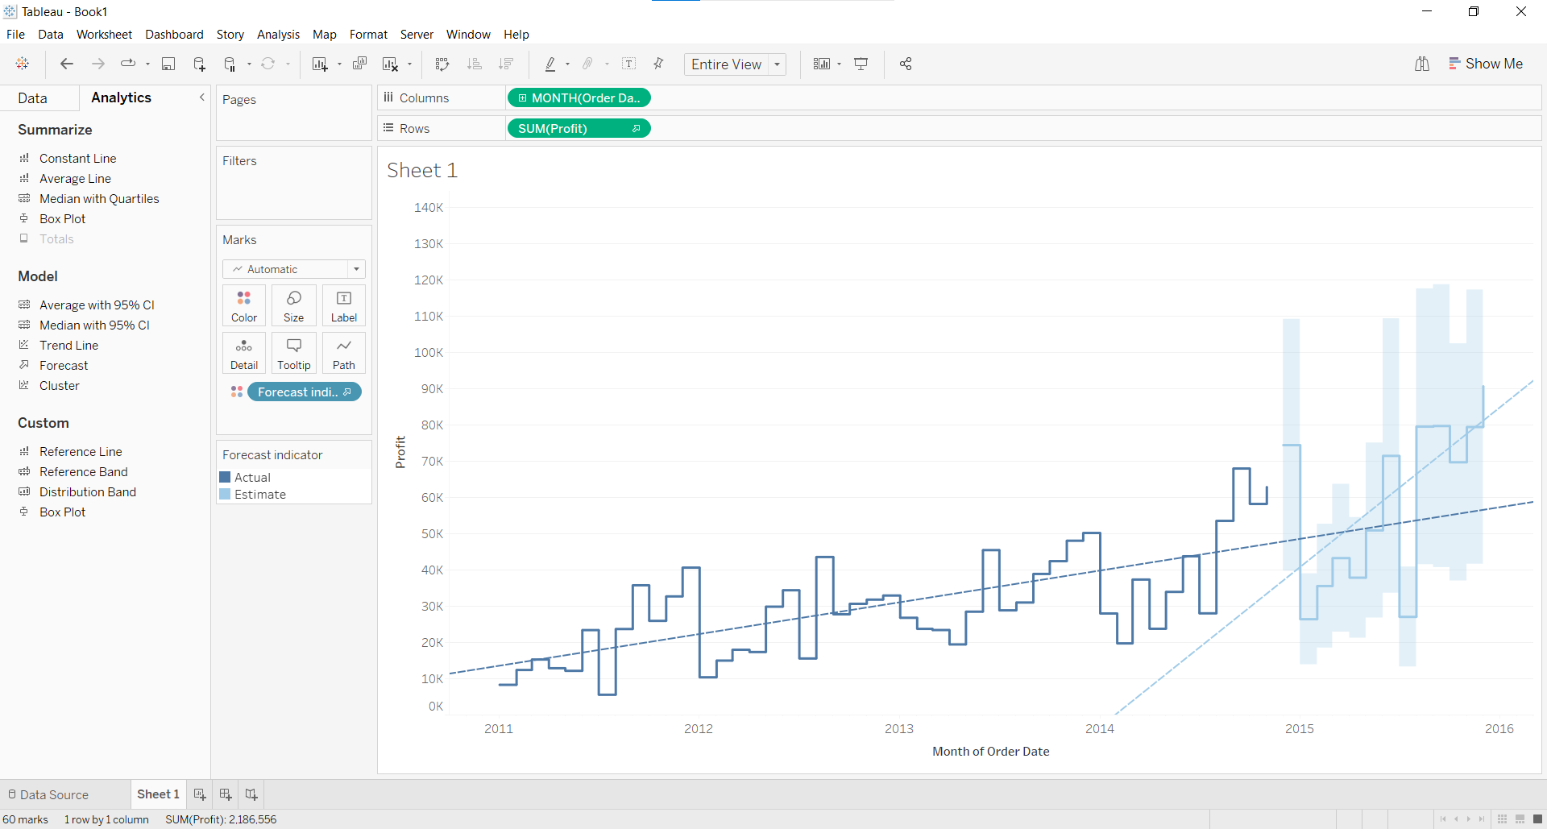

Exponential Trend:
Automatic
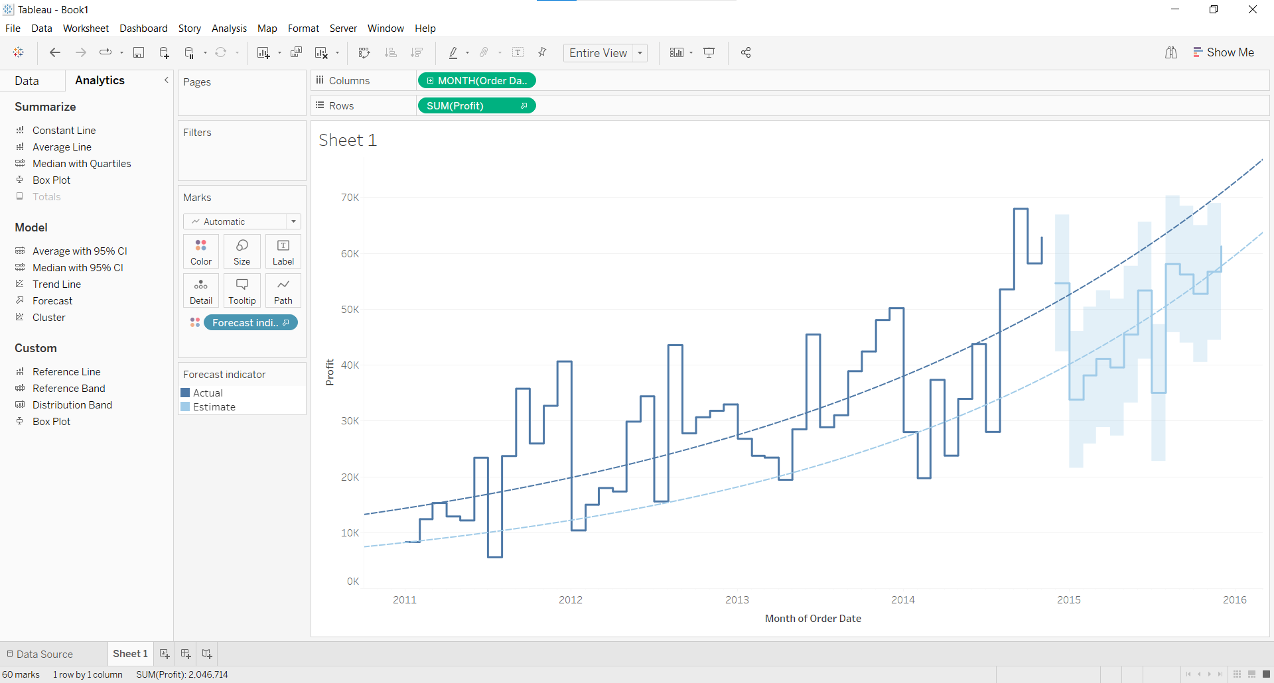
Automatic without seasoning
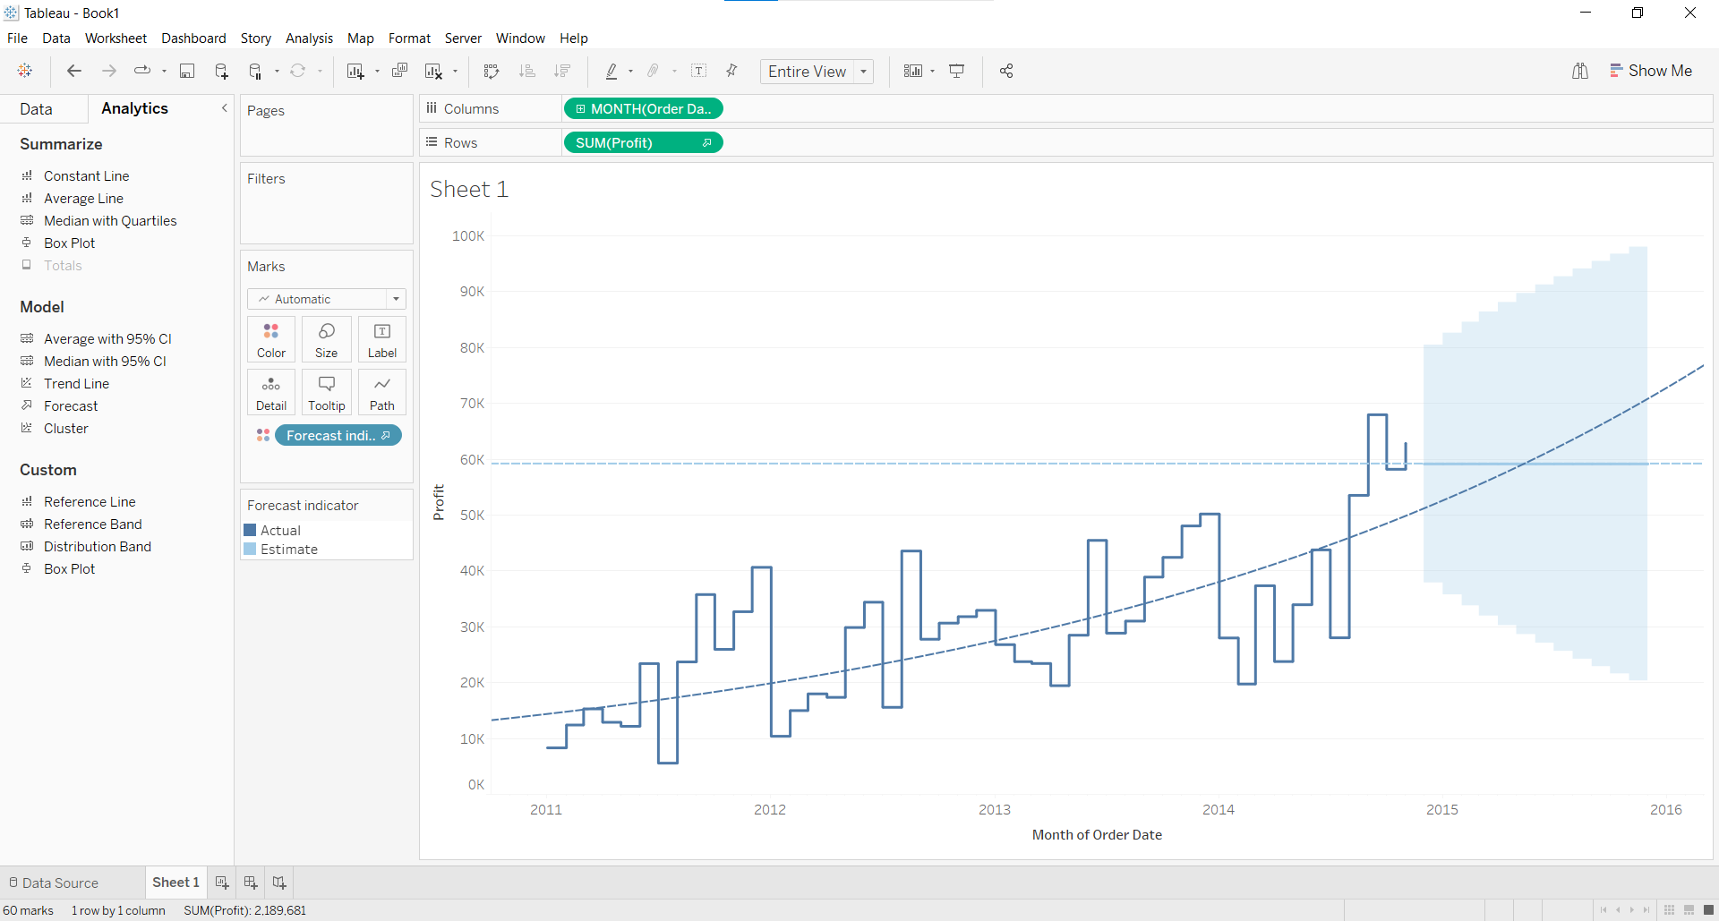

Additive Trend and Additive Seasonality
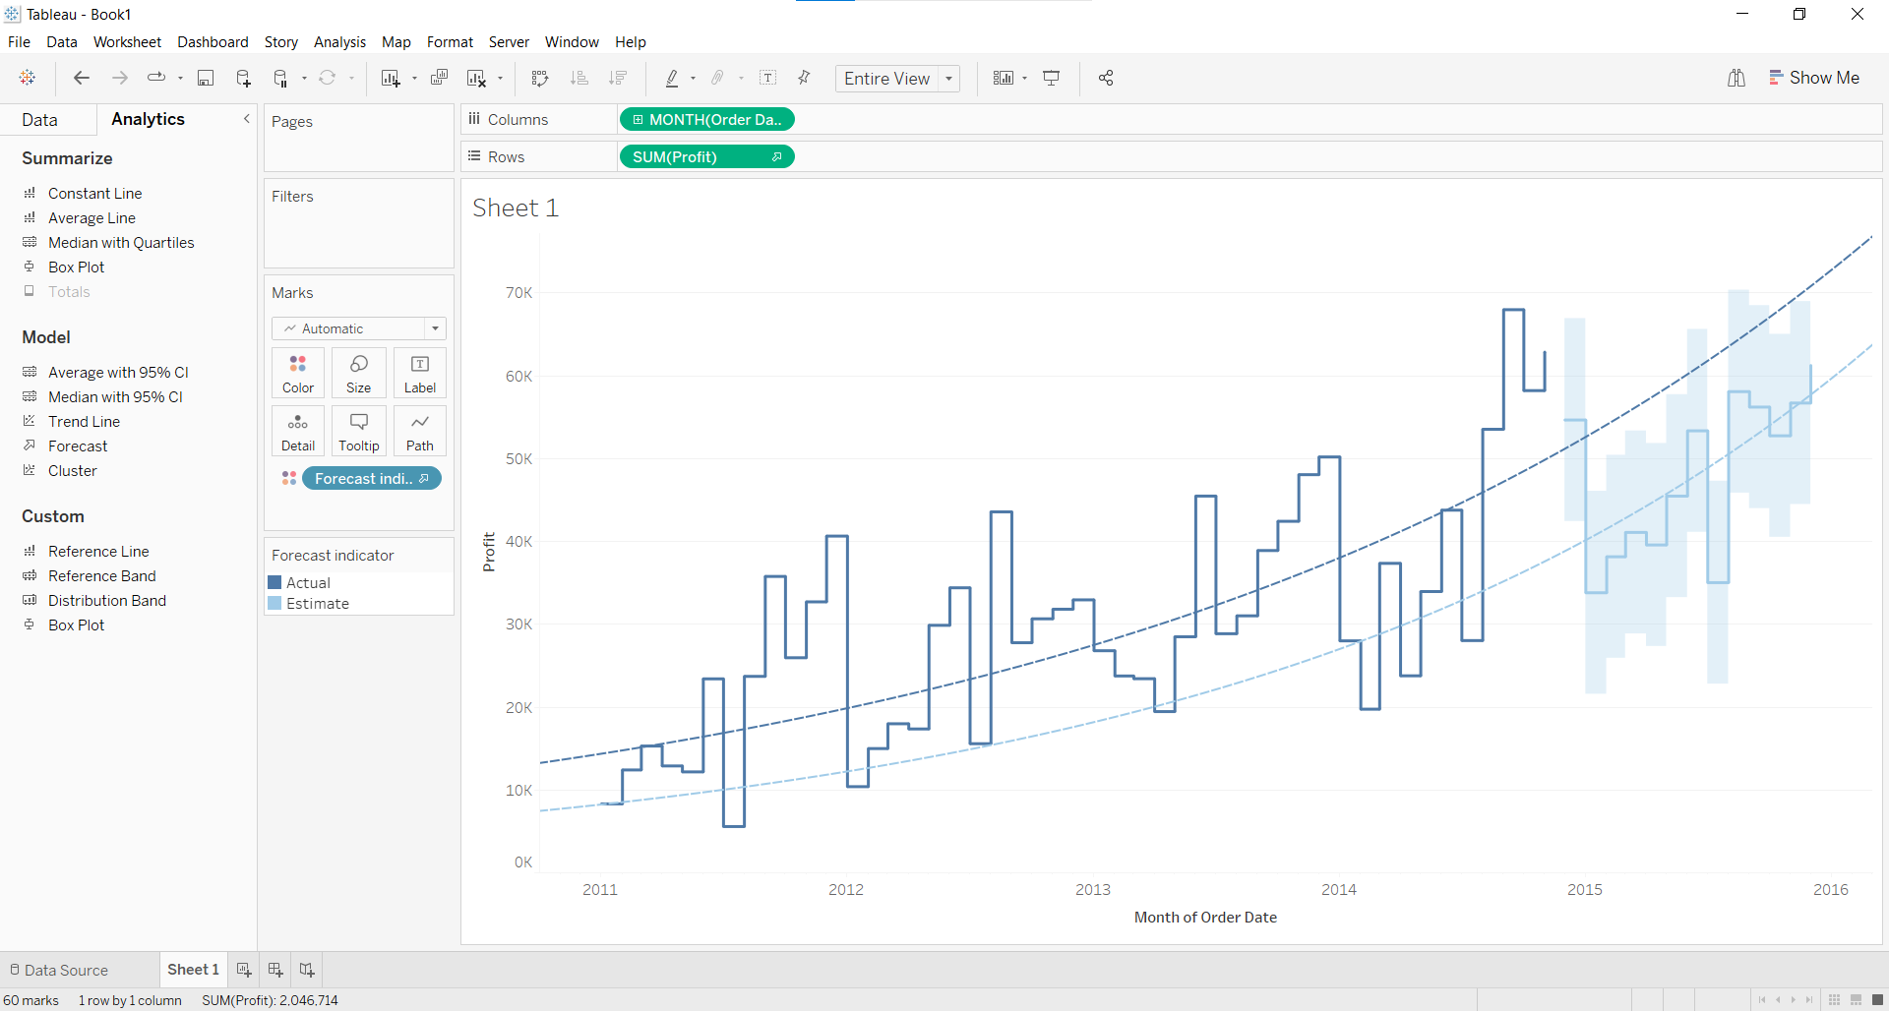
Additive Trend and Multiplicative Seasonality
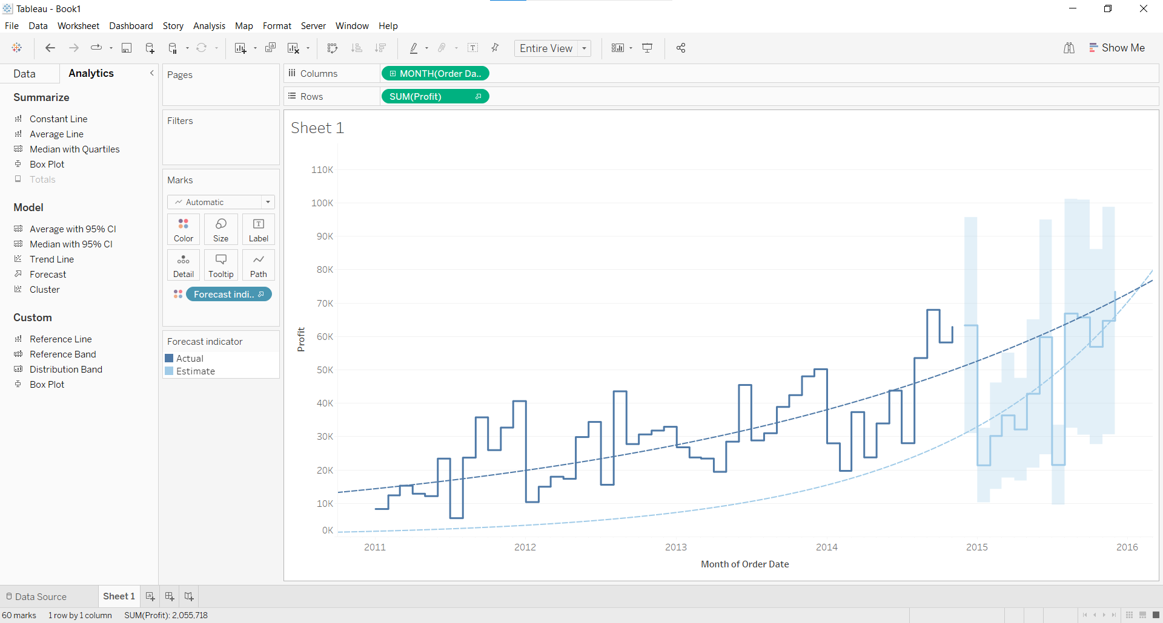
Multiplicative Trend and Multiplicative Seasonality
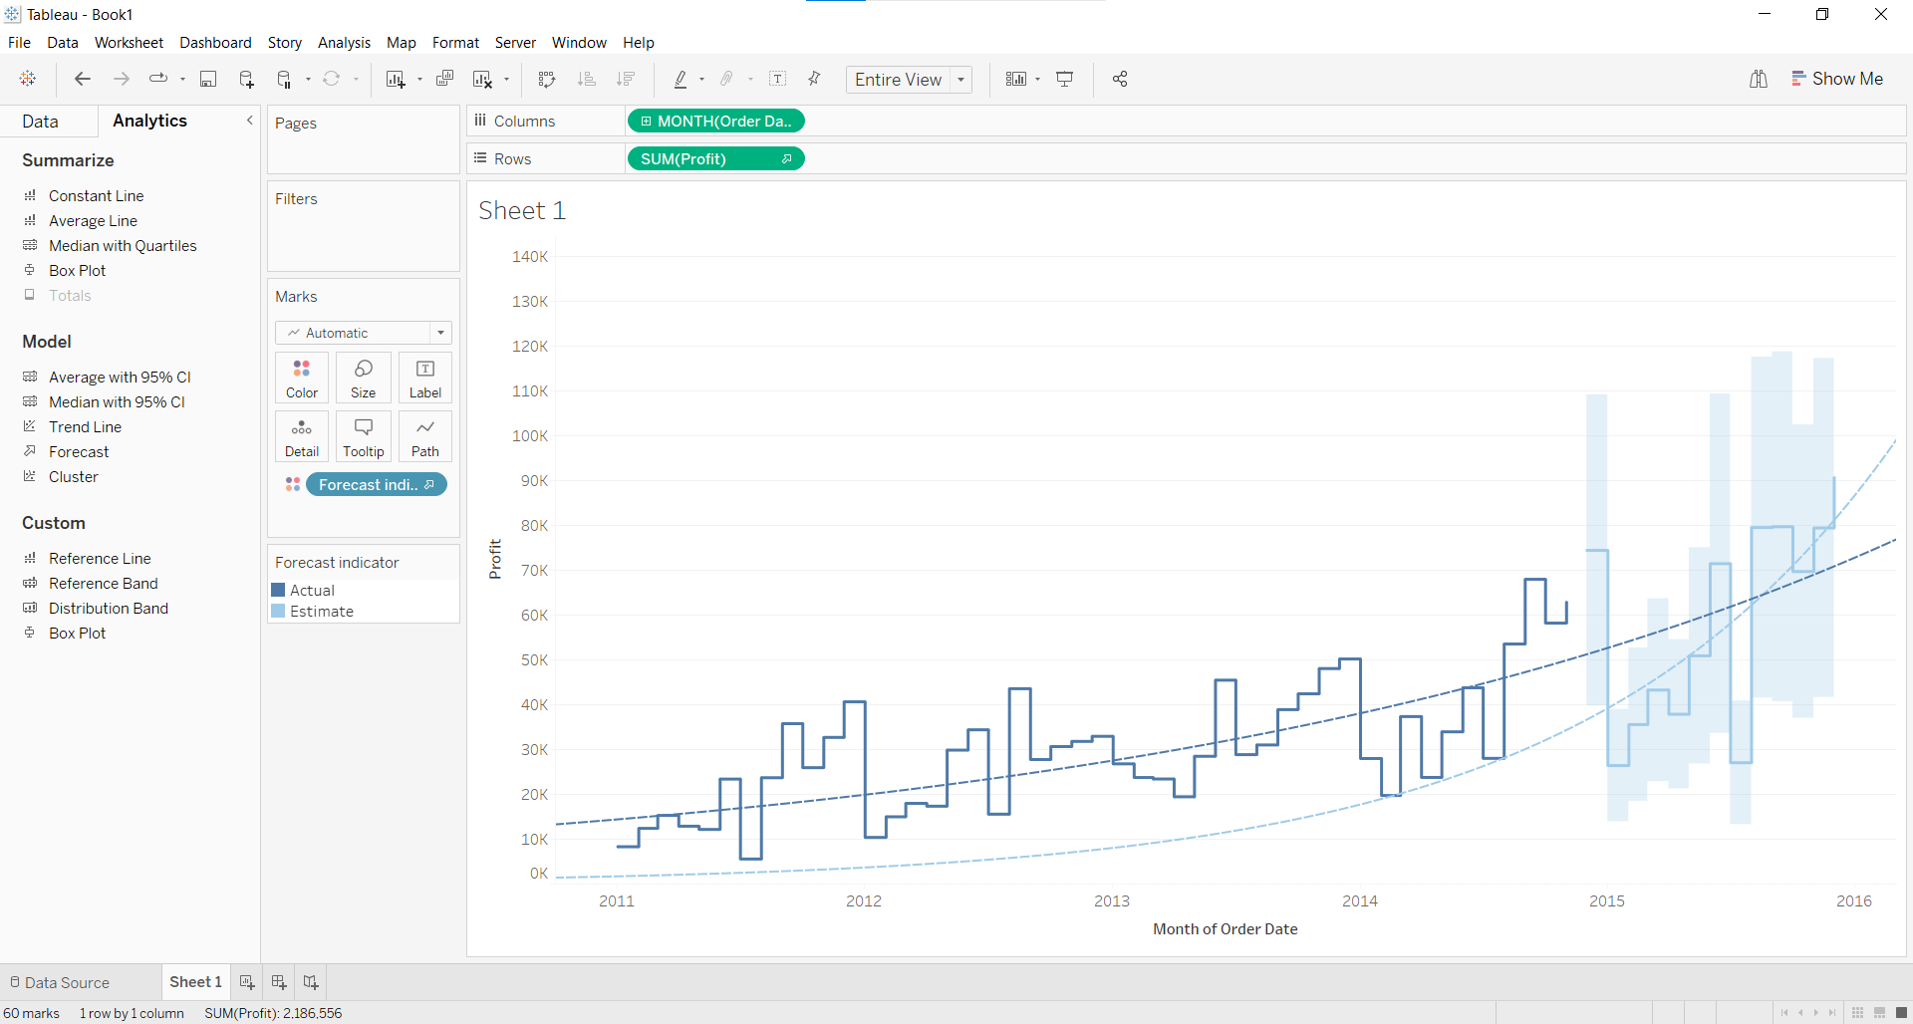

Polynomial Trend:
Automatic
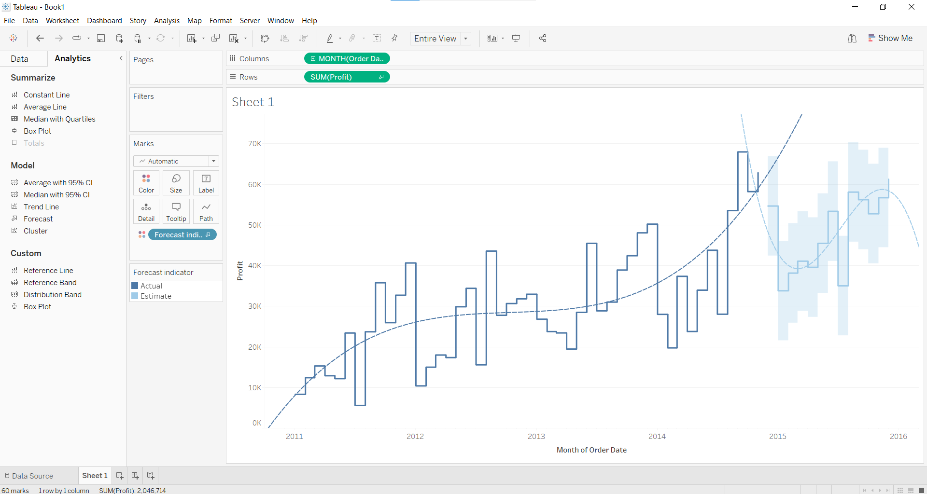
Automatic without seasoning
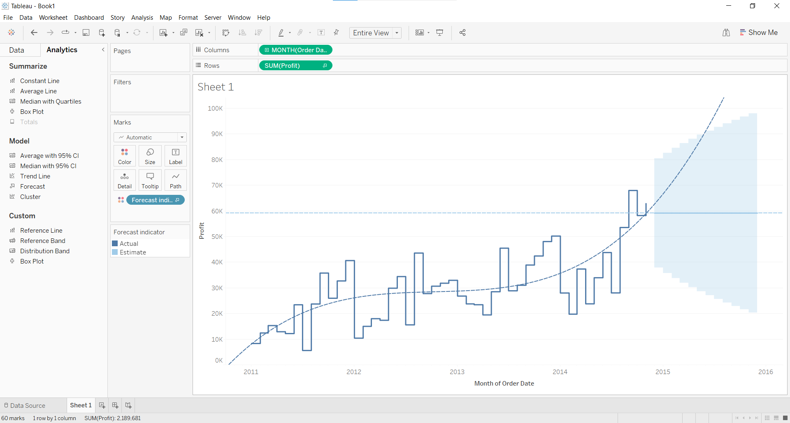

Additive Trend and Additive Seasonality
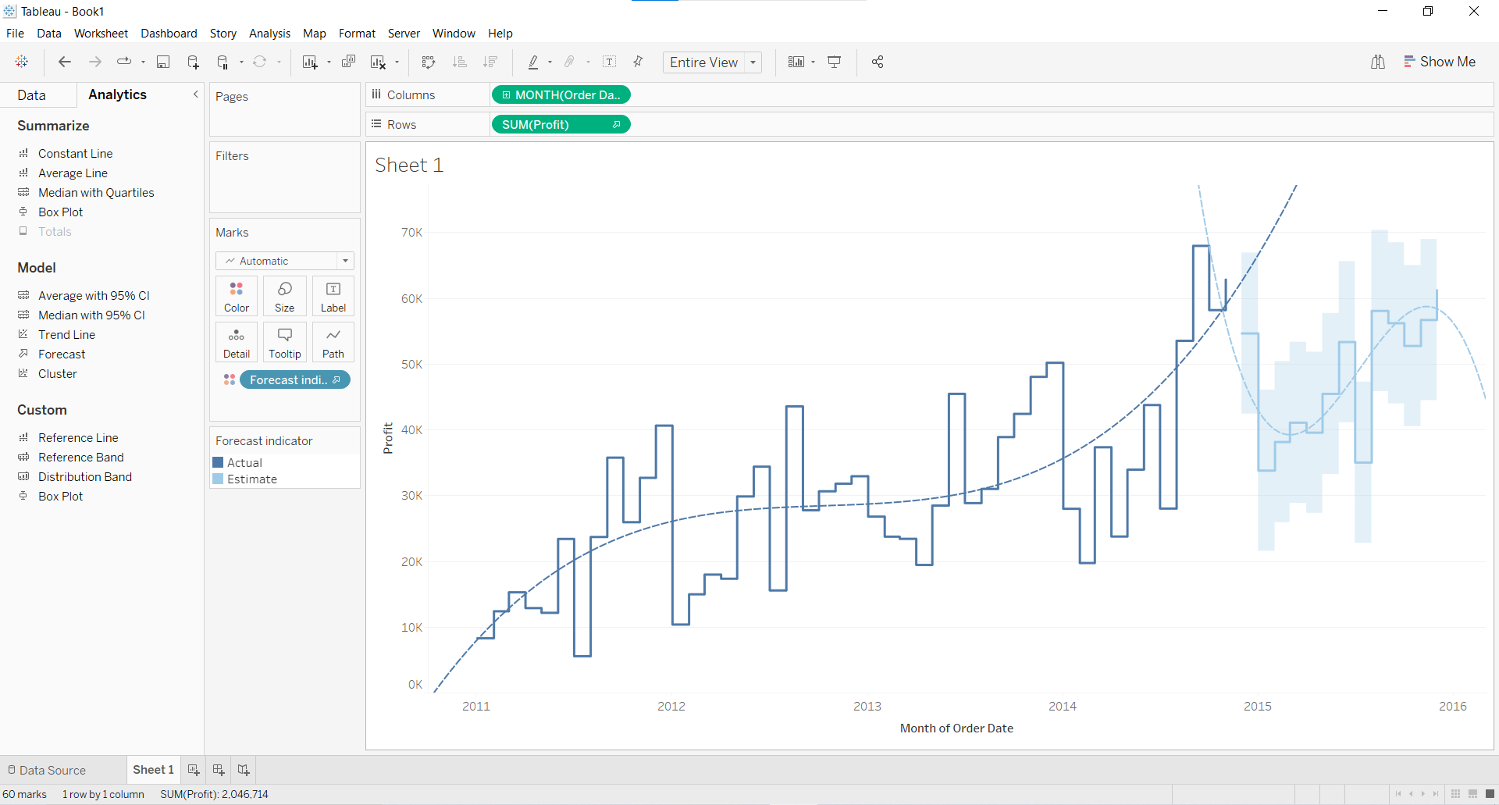
Additive Trend and Multiplicative Seasonality
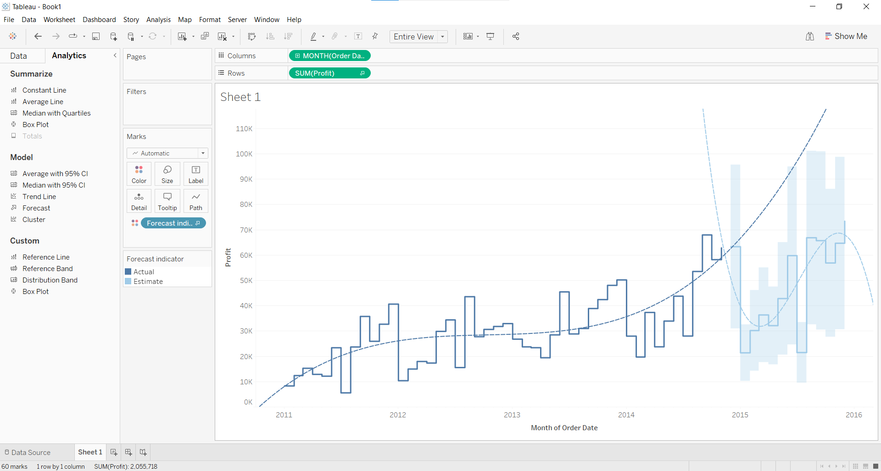
Multiplicative Trend and Multiplicative Seasonality
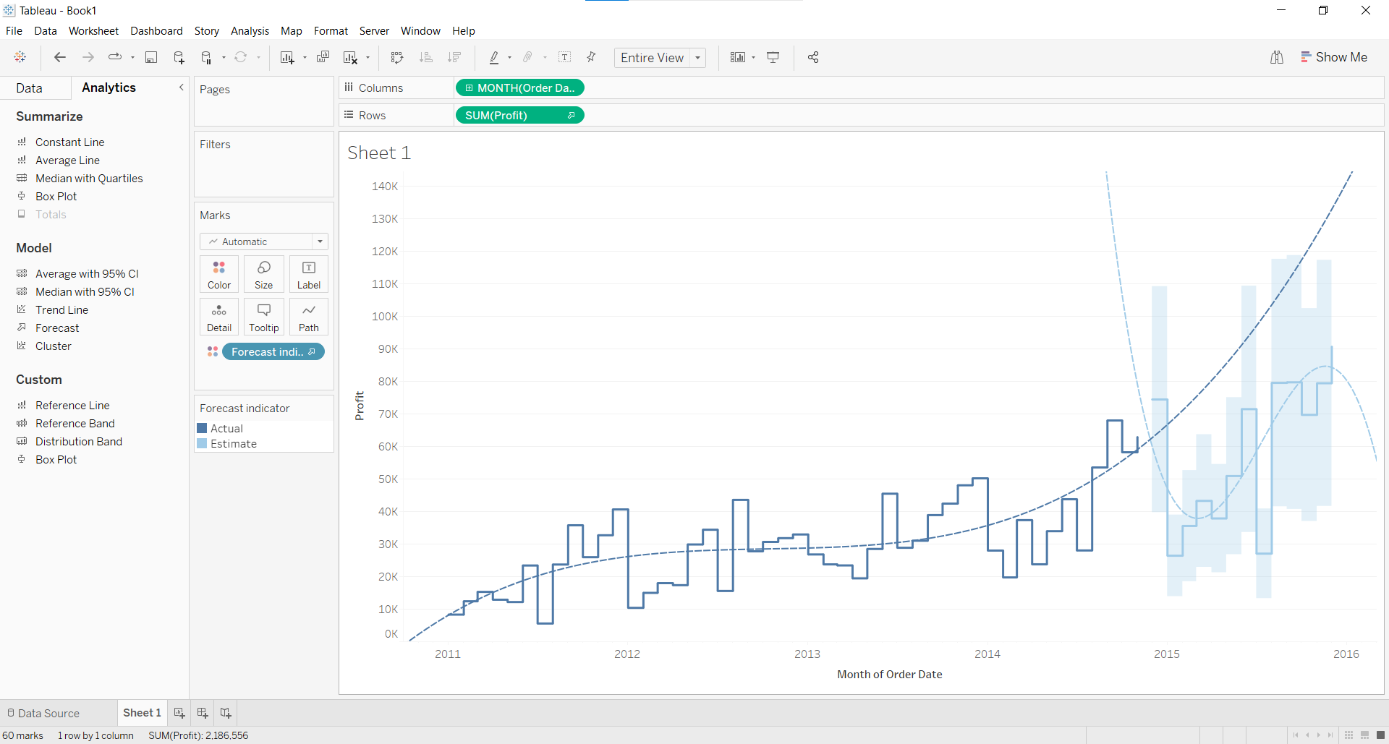
Multiplicative Trend and Additive Seasonality (in all cases)
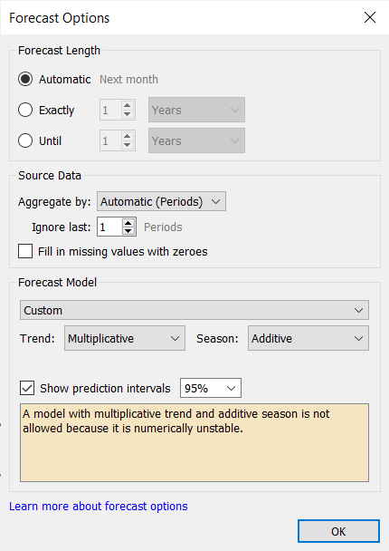

Note: Detail observation needed along screenshots wherever required

Conclusion (Students should write in their own words, comparative conclusion needed):

Downloaded the time series Data and learnt how to visualize it in Tableau, Applied trend line over visualized time series data and performed forecast over the time series using analytics options in Tableau.
Understood Additive and Multiplicative Trends and Seasonalities.

Additive trend and additive seasonality
Additive trend means the trend is linear (straight line), and additive seasonality means there aren’t any changes to widths or heights of seasonal periods over time.

Additive trend and multiplicative seasonality
Additive trend means the trend is linear (straight line), and multiplicative seasonality means there are changes to widths or heights of seasonal periods over time.

Multiplicative trend and additive seasonality
Multiplicative trend means the trend is not linear (curved line), and additive seasonality means there aren’t any changes to widths or heights of seasonal periods over time.

Multiplicative trend and multiplicative seasonality
Multiplicative trend means the trend is not linear (curved line), and multiplicative seasonality means there are changes to widths or heights of seasonal periods over time.

Post Lab Question:

Compare the additive and multiplicative model of time series
The term additive means individual components (trend, seasonality, and error) are added together.
Additive = Base + Trend + Seasonality + Error
An additive trend indicates a linear trend, and an additive seasonality indicates the same frequency (width) and amplitude (height) of seasonal cycles.
------------------------------------------------------------------------------------------------
The term multiplicative means individual components (trend, seasonality, and residuals) are multiplied together.
Multiplicative = Base × Trend × Seasonality × Error
A multiplicative trend indicates a non-linear trend (curved trend line), and a multiplicative seasonality indicates increasing/decreasing frequency (width) and/or amplitude (height) of seasonal cycles.

Date: 11/10/2022 Signature of faculty in-charge

